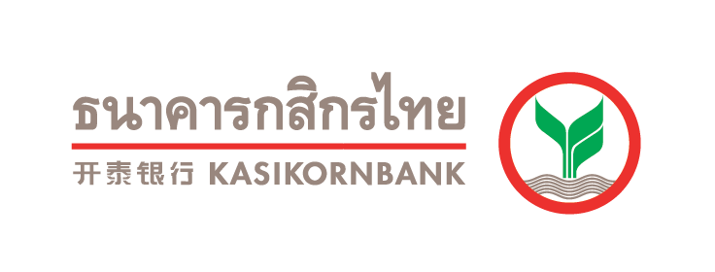


KBank partners Lazada to provide online lending for sellers, enabling more inclusive financial services through eCommerce. Customers get loan approved in one minute.

Thailand, Bangkok, 3 December 2019 - KASIKORNBANK (KBank), one of Thailand’s leading banks, is partnering with leading Southeast Asia eCommerce company Lazada to provide online lending services for the Thai sellers on the eCommerce platform. This will enable the sellers to access financing at their fingertips, with instant approval, minimal documentation required and zero fees. Customers can get the loan within one minute. The ease and speed afforded to the sellers will provide them with timely funds that will be needed to meet business needs, as well as to grow it. At the end of 2020, KBank aims to lend 1 billion Baht in this type of loan.
Mr. Jack Zhang, Deputy CEO of Lazada Thailand, said technology can be leveraged to unlock more growth opportunities for financial institutions and small businesses. “With this new lending model that removes the tedious manual process of assessing and validating information, a seller can apply and get cash instantly for a loan on his phone. With the partnership, we look forward to enabling more inclusive financial services for the many small businesses and sellers on our platform, as part of our mission to make it easy to business anywhere.”
Mr. Wirawat Panthawangkun, KBank Senior Executive Vice President, said that amid the present e-commerce craze in Thailand, online trading has seen brisk sales. As this channel continues to surge in popularity among traders, newcomers have recently jumped onto the bandwagon. However, access to funding sources is among their top pain points due to several hindrances such as insufficient documents and collateral to support loan application and having no bank account; such circumstances mean that they cannot apply for loan from financial institutions.
Under the “Better Together” collaboration between KBank and Lazada, sellers on Lazada are able to gain access to low-interest loans, without the need to provide collateral or documentation and no fees. Loan can be approved within one minute. The loan limit of 600,000 Baht ensures that Lazada merchants have enough working capital for their business needs. At the end of 2020, KBank aims to lend 1 billion Baht in this type of loan.

-2-
The loan application process is made possible by connecting Lazada Seller Center’s API and the K PLUS application, making it a one-stop shop. The service presents a new borrowing experience, allowing borrowers to gain access to the loan at their fingertips within only one minute. In a pilot with Lazada’s merchants, KBank has received positive feedback. Moreover, KBank aims to enhance sellers’ capacity via the MADCOURSE online course, allowing them to study 24/7; and offers MADDEAL, or discounts for transport and packaging fees at www.kasikornbank.com/MADHUB, to help entrepreneurs grow their business.
Moreover, this one-stop loan service launches just in time for Lazada merchants to scale their business upon the year-end shopping season. Lazada will kick off its last mega shopping event of the year, the '12.12 Grand Year End Sale', during the three-day sale held on 12 – 14 December, building on the momentum of the hugely successful 11.11 campaign.
###
About Lazada Group
Founded in 2012, Lazada Group is the leading eCommerce platform in Southeast Asia. We are accelerating progress in Indonesia, Malaysia, the Philippines, Singapore, Thailand and Vietnam through commerce and technology. With the largest logistics and payments networks in the region, Lazada is a part of our consumers’ daily lives in the region and we aim to serve 300 million shoppers by 2030. Since 2016, Lazada is the Southeast Asia flagship platform of the Alibaba Group powered by its cutting-edge technology infrastructure.
About KASIKORNBANK
​​The KASIKORNBANK Public Company Limited was established on June 8, 1945. Throughout the past 70 years, the Bank has always strived to develop our organization and offer financial product initiatives plus excellent service delivery to match our slogan, “Towards Service Excellence” and “Customer Centricity” concept. This led to the consolidation of KASIKORNBANK and subsidiaries (K Companies) and “K KASIKORNTHAI” symbol was adopted to guarantee quality and standards.
KASIKORNBANK aims to be a most innovative, dynamic, and proactive customer-centric financial institution that creates sustainability for all stakeholders and aims to harmoniously combine technology and human resources to sustainably create world-class-quality financial services, so as to achieve optimal benefits for all stakeholders.

Media Contact
Public Relations Lazada Thailand
Titiwanlaya Thaimongkolrat 083-964-6649 E-mail: titiwanlaya.thaimongkolrat@lazada.co.th
Panita Burakamkovit 081-493-2229 E-mail: p.burakamkovit@lazada.co.th

For media inquiries please contact: a publicist Tel. 02 064 2794
Khun Arpaporn (A) 089 788 4868, Khun Thittaya (Jang) 094 323 5641, Khun Tharantikorn (Ple) 089 884 0219

